|  |  | **DELIVERY CHALLAN** | | | | | | | | | | | |  |  |
| --- | --- | --- | --- | --- | --- | --- | --- | --- | --- | --- | --- | --- | --- | --- | --- |
|  |  |  |  |  |  |  |  |  |  |  |  |  |  |  |  |
|  |  | **Delivery Challan No.:** | | |  | | | |  |  |  |  |  |  |  |
|  |  |  |  |  |  |  |  |  |  |  |  |  |  |  |  |
|  |  | **Company Name:** | |  | | | | | |  | **Order Date:** |  |  |  |  |
|  |  | **Address:** | |  | | | | | |  |  |  |  |  |  |
|  |  |  | | | | | |  | **Dispatch Date:** |  |  |  |  |
|  |  |  | | | | | |  |  |  |  |  |  |
|  |  | **GSTIN:** | |  | | | | | |  |  |  |  |  |  |
|  |  | **Phone:** | |  | | | | | |  |  |  |  |  |  |
|  |  |  |  |  |  |  |  |  |  |  |  |  |  |  |  |
|  |  |  | | | | | | | | | | | |  |  |
|  |  |  |  |  |  |  |  |  |  |  |  |  |  |  |  |
|  |  | **Bill To:** | |  |  |  |  |  |  |  | **Challan Date:** |  |  |  |  |
|  |  | **Name:** | |  | | | | | |  | **Ref No:** |  |  |  |  |
|  |  | **Address:** | |  | | | | | |  | **Challan Type:** |  |  |  |  |
|  |  |  | | | | | |  |  |  |  |  |  |
|  |  |  | | | | | |  | **GSTIN:** |  |  |  |  |
|  |  | **GSTIN:** | |  | | | | | |  |  |  |  |  |  |
|  |  | **Phone:** | |  | | | | | |  |  |  |  |  |  |
|  |  | **Place of Supply:** | |  | | | | | |  |  |  |  |  |  |
|  |  |  |  |  |  |  |  |  |  |  |  |  |  |  |  |
|  |  |  |  |  |  |  |  |  |  |  |  |  |  |  |  |
|  |  | **SR No.** | **ITEM DESCRIPTION** | **HSN/SAC** | **QTY** | **PRICE/ITEM** | **TAXABLE VALUE** | **CGST** | | **SGST** | | **IGST** | |  |  |
|  |  | **RATE** | **AMT** | **RATE** | **AMT** | **RATE** | **AMT** |  |  |
|  |  | 1 |  |  |  |  | 0 |  | 0 |  | 0 | 0 | 0 |  |  |
|  |  | 2 |  |  |  |  | 0 |  | 0 |  | 0 | 0 | 0 |  |  |
|  |  | 3 |  |  |  |  | 0 |  | 0 |  | 0 | 0 | 0 |  |  |
|  |  | 4 |  |  |  |  | 0 |  | 0 |  | 0 | 0 | 0 |  |  |
|  |  | 5 |  |  |  |  | 0 |  | 0 |  | 0 | 0 | 0 |  |  |
|  |  |  |  |  |  |  |  |  |  |  |  |  |  |  |  |
|  |  |  |  |  |  |  |  |  |  |  |  |  |  |  |  |
|  |  |  |  |  |  |  |  |  |  |  |  |  |  |  |  |
|  |  |  |  |  |  |  |  |  |  | Sub Total: | | 0 |  |  |  |
|  |  |  |  |  |  |  |  |  |  | Total Tax: | | 0 |  |  |  |
|  |  |  |  |  |  |  |  |  |  | Rounded Off: | | 0 |  |  |  |
|  |  |  |  |  |  |  |  |  |  | **Grand Total:** | | 0 |  |  |  |
|  |  |  |  |  |  |  |  |  |  |  |  |  |  |  |  |
|  |  | Notes: | | | | | | | | | | | |  |  |
|  |  |  |  |
|  |  |  |  |
|  |  |  |  |  |  |  |  |  |  |  |  |  |  |  |  |

| **Create Delivery Challans in Kladana** | | | | | | | | | |
| --- | --- | --- | --- | --- | --- | --- | --- | --- | --- |
|
| In Kladana you can create, save, and print Delivery Challans based either on shipment, or on transfers | | | | | | | | | |
|
|

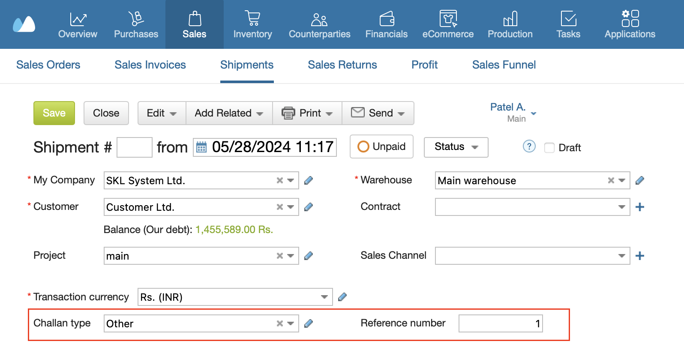

|  |  |
| --- | --- |
| [**Start a Free 14-Day Trial**](https://www.kladana.com/signup/?q=leadmagnet&utm_medium=leadmagnet&utm_source=marketing-tool&utm_campaign=leadmagnet-delivery-challan-template) | [**Choose your next Plan**](https://www.kladana.com/pricing/?utm_medium=leadmagnet&utm_source=marketing-tool&utm_campaign=leadmagnet-delivery-challan-template) |
| *With no limits* | *Starting with $60 per Year* |
|  |  |
| **Subscribe:** [**LinkedIn**](https://www.linkedin.com/company/kladana/) **&** [**Youtube**](https://www.youtube.com/channel/UCrdFisBhmdOWpbaQ0v9LrZA) | [**Read our Articles & Case Stories**](https://www.kladana.com/blog/?utm_medium=leadmagnet&utm_source=marketing-tool&utm_campaign=leadmagnet-delivery-challan-template) |