|  |  | | | | | | |  |
| --- | --- | --- | --- | --- | --- | --- | --- | --- |
|  | **Delivery Challan** | | | | | | |  |
|  |  |  | |  |  |  |  |  |
|  | **Company Name:** | | | | | **Add your logo here** | |  |
|  | Address: |  | | | |  |
|  |  | | | | |  |
|  | Phone No.: |  | | | |  |
|  | Email: |  | | | |  |
|  | GSTIN: |  | | | |  |
|  |  | | | | | | |  |
|  | Delivery Challan For: | | Shipping To: | | | | |  |
|  | **Party Name:** | | **Shipping Name:** | | | | |  |
|  | Address: |  | Address: | | |  | |  |
|  |  | |  | | | | |  |
|  | Phone No.: |  | Phone No.: | | |  | |  |
|  | Email: |  | Email: | | |  | |  |
|  | GSTIN: |  | GSTIN: | | |  | |  |
|  |  | |  | | | | |  |
|  | Challan No.: |  | Delivery time: | | |  | |  |
|  | Date: |  |  | | | | |  |
|  |  | | | | | | |  |
|  | **Sl No.** | **Item Name** | **HSN/SAC Code** | | | **Quantity** | **Unit** |  |
|  | 1 | Item Name 1 | 1234 | | | 5 | Bag |  |
|  | 2 | Item Name 2 | 1234 | | | 12 | Box |  |
|  | 3 | Item Name 3 | 1234 | | | 14 | Unit |  |
|  | 4 | Item Name 8 | 1234 | | | 12 | Unit |  |
|  | **Total** | | | | | **104** |  |  |
|  |  | | | | | | |  |
|  | **Terms and conditions:** | | **For, Company Name**  **Authorised Signature** | | | | |  |
|  | **Recieved By** Name: Comment: Date: Signature: | | **Delivered By** Name: Comment: Date: Signature: | | | | |  |
|  |  | | | | | | |  |
|  |  | | | | | | |  |

| **Create Delivery Challans in Kladana** | | | | | | | | | |
| --- | --- | --- | --- | --- | --- | --- | --- | --- | --- |
|
| In Kladana you can create, save, and print Delivery Challans based either on shipment, or on transfers | | | | | | | | | |
|
|

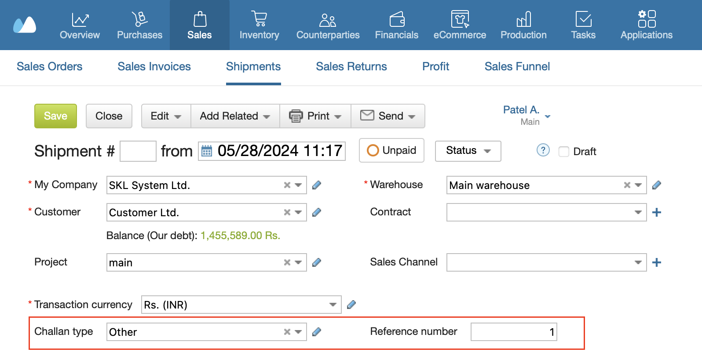

|  |  |
| --- | --- |
| [**Start a Free 14-Day Trial**](https://www.kladana.com/signup/?q=leadmagnet&utm_medium=leadmagnet&utm_source=marketing-tool&utm_campaign=leadmagnet-delivery-challan-template) | [**Choose your next Plan**](https://www.kladana.com/pricing/?utm_medium=leadmagnet&utm_source=marketing-tool&utm_campaign=leadmagnet-delivery-challan-template) |
| *With no limits* | *Starting with $60 per Year* |
|  |  |
| **Subscribe:** [**LinkedIn**](https://www.linkedin.com/company/kladana/) **&** [**Youtube**](https://www.youtube.com/channel/UCrdFisBhmdOWpbaQ0v9LrZA) | [**Read our Articles & Case Stories**](https://www.kladana.com/blog/?utm_medium=leadmagnet&utm_source=marketing-tool&utm_campaign=leadmagnet-delivery-challan-template) |