**BILL OF MATERIALS TEMPLATE**

| **PRODUCT NAME** |  | **CONTACT INFO** | **PRODUCT ASSEMBLY IMAGE** |
| --- | --- | --- | --- |
| **APPROVED BY** |  |  |
| **DATE OF APPROVAL** |  |  |
| **PART COUNT** |  |  |
| **TOTAL COST** |  |  |

| **PART NUMBER** | **PART NAME** | **DESCRIPTION** | **QTY** | **UNITS** | **PART IMAGE** | **UNIT COST** | **AMOUNT** |
| --- | --- | --- | --- | --- | --- | --- | --- |
|  |  |  |  |  |  |  |  |
|  |  |  |  |  |  |  |  |
|  |  |  |  |  |  |  |  |
|  |  |  |  |  |  |  |  |
|  |  |  |  |  |  |  |  |
|  |  |  |  |  |  |  |  |
|  |  |  |  |  |  |  |  |
|  |  | **TOTAL PARTS** |  |  |  | **TOTAL** |  |

| **Create BOMs in Kladana** | | | | | | | | | |
| --- | --- | --- | --- | --- | --- | --- | --- | --- | --- |
|
| In Kladana you can create, save, and print Bills of Materials | | | | | | | | | |
|
|

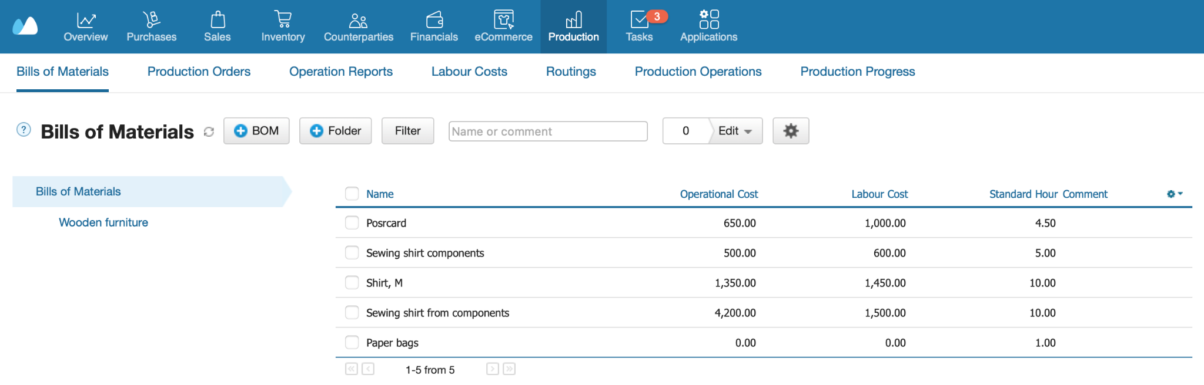

|  |  |
| --- | --- |
| [**Start a Free 14-Day Trial**](https://www.kladana.com/signup/?ms_source=blog) | [**Choose your next Plan**](https://www.kladana.com/pricing/?utm_medium=blog&utm_source=kladana-blog&utm_campaign=bom-template) |
| *With no limits* | *Starting with $60 per Year* |
|  |  |
| **Subscribe:** [**LinkedIn**](https://www.linkedin.com/company/kladana/) **&** [**Youtube**](https://www.youtube.com/channel/UCrdFisBhmdOWpbaQ0v9LrZA) | [**Read our Articles & Case Stories**](https://www.kladana.com/blog/?utm_medium=blog&utm_source=kladana-blog&utm_campaign=bom-template) |