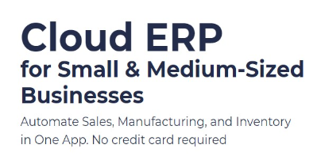 | 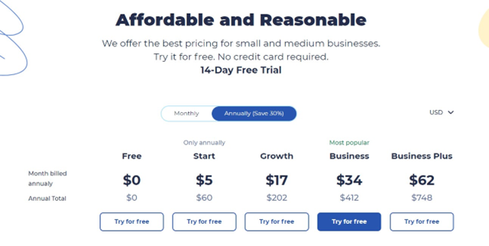
Start a Free 14-Day Trial | Choose your next Plan
With no limits | Starting with $60 per Year
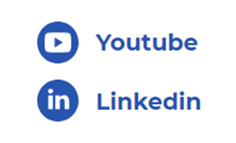 | 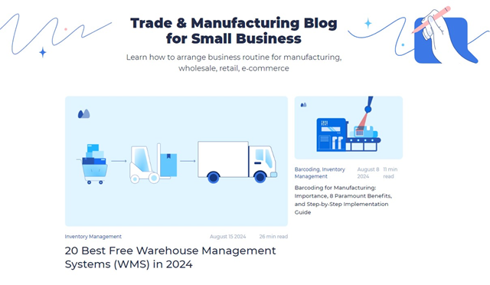
Subscribe: LinkedIn & Youtube | Read our Articles & Case Stories

