| **E-Way Bill** | | | | | | | | | | | |
| --- | --- | --- | --- | --- | --- | --- | --- | --- | --- | --- | --- |
| **E-WAY BILL Details** | | | | | | | | | | | |
| E-way Bill No: | | | Generated Date: | | | Generated By: | | | | | |
| Valid Upto: | | | | | |
| Mode: | | | Approx Distance: | | |  | | | | | |
| Type: | | | Document Details: | | | Transaction type: | | | | | |
| **Address Details** | | | | | | | | | | | |
| **Dispatch From** | | | |  | **Ship To** | | | | | | |
| GSTIN:  <Company Name here>  <State> | | | |  | GSTIN:  <Company Name Here>  <State> | | | | | | |
| **Goods Details** | | | | | | | | | | | |
| **HSN**  **Code** | **Product Name & Desc** | | | | **Quantity** | **Taxable Amount** | **Tax Rate (C+S+I+Cess+Cess Non.Advol)** | | | | |
|  |  | | | |  |  |  |  |  |  |  |
|  |  | | | |  |  |  |  |  |  |  |
|  |  | | | |  |  |  |  |  |  |  |
|  |  | | | |  |  |  |  |  |  |  |
| **Tot. Taxable Amt** | **CGST**  **Amt** | **SGST**  **Amt** | **IGST**  **Amt** | **Cess Amt** | **Cess Non. Advol Amt** | **Other Amt** | **Tot. Inv. Amt** | | | | |
|  |  |  |  |  |  |  |  | | | | |
| **Transportation Details** | | | | | | | | | | | |
|  | | | | |  | | | | | | |
| **Vehicle Details** | | | | | | | | | | | |
| **Mode** | **Vehicle / Transport** | | **From** | **Entered Date** | **Entered By** | | **CEWB No.**  **(If any)** | | | **Multi Veh. Info (if any)** | |
|  |  | |  |  |  | |  | | |  | |

This document is made for representation purpose only.



**Create Invoices in Kladana**

**In Kladana you can create, save, and print Sales, Tax, Tax with Bank Details, and Supplier Invoices**

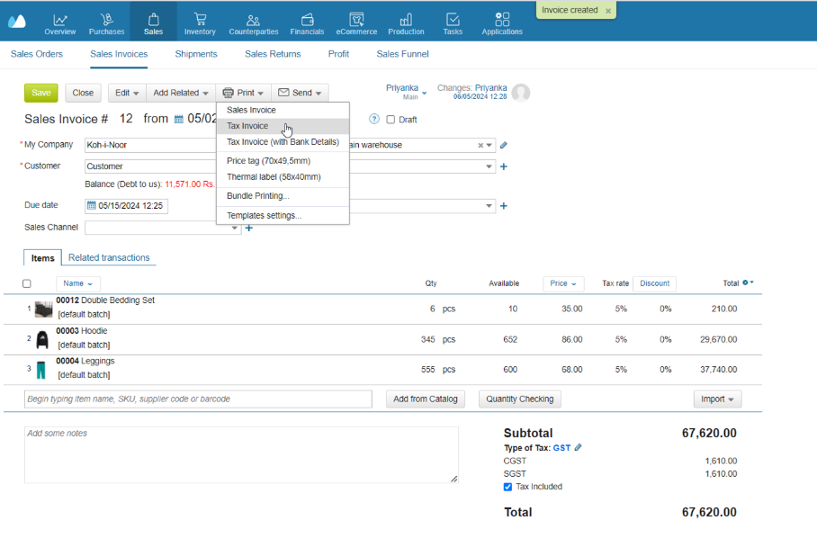

|  |  |
| --- | --- |
| [**Start a Free 14-Day Trial**](https://www.kladana.com/signup/?q=leadmagnet&utm_medium=leadmagnet&utm_source=marketing-tool&utm_campaign=leadmagnet-eway-bill-template) | [**Choose your next Plan**](https://www.kladana.com/pricing/?utm_medium=leadmagnet&utm_source=marketing-tool&utm_campaign=leadmagnet-eway-bill-template) |
| *With no limits* | *Starting with $60 per Year* |
|  |  |
| **Subscribe:** [**LinkedIn**](https://www.linkedin.com/company/kladana/) **&** [**Youtube**](https://www.youtube.com/channel/UCrdFisBhmdOWpbaQ0v9LrZA) | [**Read our Articles & Case Stories**](https://www.kladana.com/blog/?utm_medium=leadmagnet&utm_source=marketing-tool&utm_campaign=leadmagnet-eway-bill-template) |